Night Time Light (NTL) Urban Settlement Indices Implementation on ROI Image (Bahria Town Phase 7)

First we extract a landsat 8 image over Bahria Town Phase-7, Rawalpindi area, using a 2 km buffer and a time range from January 2023 to July 2025. The workflow begins by selecting the clearest Landsat 8 scene in the period, masking out clouds and invalid pixels, and exporting all 11 optical and thermal bands for analysis. It also generates a basic urban mask by combining NDBI and NDVI thresholds to identify built-up areas, which is exported as a separate raster. It incorporates NOAA’s VIIRS Nighttime Lights (NTL) monthly composites to compute both the maximum and 90th percentile brightness values across the time period, exporting both at 30-meter resolution to align with Landsat. To capture seasonal light variation, it also creates and exports a 3-band NTL composite using January, May, and September images. For vegetation monitoring, the code calculates the Enhanced Vegetation Index (EVI) and the Normalized Difference Vegetation Index (NDVI) for every Landsat scene, then computes and exports their pixelwise maximum values as separate layers. Additionally, it calculates the Urban Built-Up Index (UBI) from Landsat, exporting its annual maximum as well. Finally, the script provides quick visual previews of the results and exports all processed images—including the Landsat stack, vegetation indices, UBI, urban mask, and NTL layers—to Google Drive for further analysis in Python or GIS. In short, this script automates the preparation of key urban and vegetation indicators for your study area, ready for advanced index computation and urban analysis. Dynamic World Labels classes were used as classes for the mask. Dynamic World Labels has class names:
- Water
- Trees
- Grass
- Flooded Vegetation
- Crops
- Shrub & Scrub
- Built
- Bare
- Snow & Ice
The code used for extraction was:
/********************* USER SETTINGS **************************/
var BUFFER_METERS = 2000; // ~2 km radius
var DATE_START = '2023-01-01';
var DATE_END = '2025-07-01';
var CLOUD_THRESH = 10; // % cloud cover (scene-wide)
var DRIVE_FOLDER = 'GEE_Exports'; // change if you like
/****************************************************************/

// 1. ROI: Bahria Town Phase-7, Rawalpindi
var roi = ee.Geometry.Point(73.11988, 33.53081).buffer(BUFFER_METERS);

// 2. Landsat-8 TOA collection (includes PAN + TIRS 2)
var col = ee.ImageCollection('LANDSAT/LC08/C02/T1_TOA')
.filterBounds(roi)
.filterDate(DATE_START, DATE_END)
.filter(ee.Filter.lt('CLOUD_COVER', CLOUD_THRESH))
.sort('CLOUD_COVER');

// 3. Pick the **first** scene after sorting (lowest cloud)
var l8 = ee.Image(col.first());

// 4. QA-based valid-pixel mask (remove cloud / cirrus / fill)
var qa = l8.select('QA_PIXEL');
var good = qa.bitwiseAnd(1 << 0).eq(0) // fill
.and(qa.bitwiseAnd(1 << 1).eq(0)) // dilated cloud
.and(qa.bitwiseAnd(1 << 2).eq(0)) // cirrus
.and(qa.bitwiseAnd(1 << 3).eq(0)); // cloud
l8 = l8.updateMask(good).clip(roi);

// 5. ALL 11 BANDS (B1…B11)
var allBands = l8.select([
'B1','B2','B3','B4','B5','B6','B7',
'B8', // PAN (15 m)
'B9', // Cirrus
'B10','B11'// TIRS 1 & 2
]);

// 6. QUICK URBAN MASK (NDBI>0 & NDVI<0.2)
var ndvi = l8.normalizedDifference(['B5','B4']).rename('NDVI');
var ndbi = l8.normalizedDifference(['B6','B5']).rename('NDBI');
var urbanMask = ndbi.gt(0).and(ndvi.lt(0.2))
.rename('urban_mask');

// 7. VIIRS Nighttime Lights extraction (median composite for time range)
var viirs_col = ee.ImageCollection("NOAA/VIIRS/DNB/MONTHLY_V1/VCMCFG")
.filterBounds(roi)
.filterDate(DATE_START, DATE_END)
.select('avg_rad');

// 2. Create a per-pixel max composite (annual max)
var viirs_ntl_max = viirs_col.max().clip(roi);

// 3. Optionally, 90th percentile instead of strict max:
var viirs_ntl_p90 = viirs_col.reduce(ee.Reducer.percentile([90])).select('avg_rad_p90').clip(roi);

// 4. Export as before
Export.image.toDrive({
image: viirs_ntl_max,
description: 'VIIRS_NTL_MAX_BahriaPhase7',
folder: DRIVE_FOLDER,
fileNamePrefix: 'VIIRS_NTL_MAX_BahriaPhase7_' + DATE_START.replace(/-/g,'') + '_' + DATE_END.replace(/-/g,''),
region: roi,
scale: 30,
crs: 'EPSG:4326',
maxPixels: 1e10
});

Export.image.toDrive({
image: viirs_ntl_p90,
description: 'VIIRS_NTL_90p_BahriaPhase7',
folder: DRIVE_FOLDER,
fileNamePrefix: 'VIIRS_NTL_90p_BahriaPhase7_' + DATE_START.replace(/-/g,'') + '_' + DATE_END.replace(/-/g,''),
region: roi,
scale: 30,
crs: 'EPSG:4326',
maxPixels: 1e10
});

// 8. VISUAL PREVIEW
Map.centerObject(roi, 14);
Map.addLayer(allBands, {bands:['B4','B3','B2'], min:0.05, max:0.4}, 'L8 RGB');
Map.addLayer(urbanMask.updateMask(urbanMask), {palette:['black','red']}, 'Urban mask');
Map.addLayer(viirs_ntl_max, {min:0, max:50, palette:['black','blue','cyan','yellow','white']}, 'NTL (VIIRS)');
Map.addLayer(viirs_ntl_p90,{min:0, max:50, palette:['yellow']}, 'NTL (90 percent)');

// 9. EXPORT — 11-band image (Landsat)
Export.image.toDrive({
image: allBands,
description: 'L8_BahriaPhase7_11Bands',
folder: DRIVE_FOLDER,
fileNamePrefix: 'L8_BahriaPhase7_' + l8.date().format('yyyyMMdd').getInfo(),
region: roi,
scale: 30,
crs: 'EPSG:4326',
maxPixels: 1e10
});

// 10. EXPORT — binary urban mask (Landsat-based)
Export.image.toDrive({
image: urbanMask,
description: 'UrbanMask_BahriaPhase7',
folder: DRIVE_FOLDER,
fileNamePrefix: 'UrbanMask_BahriaPhase7_' + l8.date().format('yyyyMMdd').getInfo(),
region: roi,
scale: 30,
crs: 'EPSG:4326',
maxPixels: 1e10
});

// ******************************
// USER SETTINGS
// ******************************
var BUFFER_METERS = 2000; // ~2 km radius
var DATE_START = '2023-01-01';
var DATE_END = '2025-07-01';
var CLOUD_THRESH = 10; // % cloud cover
var DRIVE_FOLDER = 'GEE_Exports';
// ROI: Bahria Town Phase-7, Rawalpindi
var roi = ee.Geometry.Point(73.11988, 33.53081).buffer(BUFFER_METERS);

// ******************************
// IMAGE COLLECTION
// ******************************
var col = ee.ImageCollection('LANDSAT/LC08/C02/T1_TOA')
.filterBounds(roi)
.filterDate(DATE_START, DATE_END)
.filter(ee.Filter.lt('CLOUD_COVER', CLOUD_THRESH));

// ******************************
// EVI CALCULATION
// ******************************
var addEVI = function(img) {
var evi = img.expression(
'2.5 * ((NIR - RED) / (NIR + 6 * RED - 7.5 * BLUE + 1))',
{
'NIR': img.select('B5'),
'RED': img.select('B4'),
'BLUE': img.select('B2')
}
).rename('EVI');
return img.addBands(evi);
};
var col_evi = col.map(addEVI);

// ******************************
// NDVI CALCULATION
// ******************************
var addNDVI = function(img) {
var ndvi = img.normalizedDifference(['B5', 'B4']).rename('NDVI');
return img.addBands(ndvi);
};
var col_ndvi = col.map(addNDVI);

// ******************************
// MAX COMPOSITES
// ******************************
var evi_max = col_evi.select('EVI').max().clip(roi);
var ndvi_max = col_ndvi.select('NDVI').max().clip(roi);

// ******************************
// EXPORT TO DRIVE
// ******************************
Export.image.toDrive({
image: evi_max,
description: 'L8_EVImax_BahriaPhase7',
folder: DRIVE_FOLDER,
fileNamePrefix: 'L8_EVImax_BahriaPhase7_' + DATE_START.replace(/-/g,'') + '_' + DATE_END.replace(/-/g,''),
region: roi,
scale: 30,
crs: 'EPSG:4326',
maxPixels: 1e10
});

Export.image.toDrive({
image: ndvi_max,
description: 'L8_NDVImax_BahriaPhase7',
folder: DRIVE_FOLDER,
fileNamePrefix: 'L8_NDVImax_BahriaPhase7_' + DATE_START.replace(/-/g,'') + '_' + DATE_END.replace(/-/g,''),
region: roi,
scale: 30,
crs: 'EPSG:4326',
maxPixels: 1e10
});

var months = [
{'name': 'Jan', 'start': '2023-01-01', 'end': '2023-01-31'},
{'name': 'May', 'start': '2023-05-01', 'end': '2023-05-31'},
{'name': 'Sep', 'start': '2023-09-01', 'end': '2023-09-30'}
];

var roi = ee.Geometry.Point(73.11988, 33.53081).buffer(2000);

var ntl_bands = [];
months.forEach(function(m) {
var viirs = ee.ImageCollection('NOAA/VIIRS/DNB/MONTHLY_V1/VCMCFG')
.filterBounds(roi)
.filterDate(m.start, m.end)
.select('avg_rad')
.mean()
.clip(roi)
.rename(m.name);
ntl_bands.push(viirs);
});

// Stack into one image with 3 bands (Jan, May, Sep)
var ntl_rgb = ntl_bands[0].addBands(ntl_bands[1]).addBands(ntl_bands[2]);

Export.image.toDrive({
image: ntl_rgb,
description: 'VIIRS_NTL_RGB_BahriaPhase7',
folder: 'GEE_Exports',
fileNamePrefix: 'VIIRS_NTL_RGB_BahriaPhase7_2023',
region: roi,
scale: 30,
crs: 'EPSG:4326',
maxPixels: 1e10
});

// User settings (as before)
var roi = ee.Geometry.Point(73.11988, 33.53081).buffer(2000);
var DATE_START = '2023-01-01';
var DATE_END = '2025-07-01';

// Function to compute UBI for one Landsat 8 image
var addUBI = function(img) {
// UBI synthetic RGB (NIR, SWIR1, 2*Red)
var nir = img.select('B5');
var swir1 = img.select('B6');
var red = img.select('B4').multiply(2);
var rgb = ee.Image.cat(nir, swir1, red).rename(['nir', 'swir1', '2red']);
// Normalize each band to 0–1 within the image
var rgb_min = rgb.reduceRegion(ee.Reducer.min(), roi, 30);
var rgb_max = rgb.reduceRegion(ee.Reducer.max(), roi, 30);
var norm = rgb.subtract(ee.Image.constant([rgb_min.get('nir'), rgb_min.get('swir1'), rgb_min.get('2red')]))
.divide(ee.Image.constant([rgb_max.get('nir'), rgb_max.get('swir1'), rgb_max.get('2red')])
.subtract(ee.Image.constant([rgb_min.get('nir'), rgb_min.get('swir1'), rgb_min.get('2red')])).add(1e-6));
// Convert to HSV, extract H and V
var hsv = norm.rgbToHsv();
var H = hsv.select('hue');
var V = hsv.select('value');
// UBI formula
var ubi = H.subtract(V).divide(H.add(V).add(1e-6)).rename('UBI');
return img.addBands(ubi);
};

// Build collection, add UBI, mask clouds as needed
var col = ee.ImageCollection('LANDSAT/LC08/C02/T1_TOA')
.filterBounds(roi)
.filterDate(DATE_START, DATE_END)
.map(addUBI);

var ubi_col = col.select('UBI');

// Compute pixelwise max
var ubi_max = ubi_col.max().clip(roi);

// Export to Drive
Export.image.toDrive({
image: ubi_max,
description: 'UBImax_BahriaPhase7',
folder: 'GEE_Exports',
fileNamePrefix: 'UBImax_BahriaPhase7_' + DATE_START.replace(/-/g,'') + '_' + DATE_END.replace(/-/g,''),
region: roi,
scale: 30,
crs: 'EPSG:4326',
maxPixels: 1e10
});

// 13. OPTIONAL: print the chosen Landsat scene ID
print('Scene chosen:', l8.id());

After downloading the images and masks. I viewed the images and masks:
import rasterio
import numpy as np
import matplotlib.pyplot as plt
from skimage.transform import resize
from matplotlib.colors import ListedColormap

# ========== FILE PATHS ==========
landsat_path = r'C:\Users\Adeel Ajmal\Downloads\L8_BahriaPhase7_20231012.tif'
label_path = r'C:\Users\Adeel Ajmal\Downloads\DynamicWorld_LandcoverLabels.tif'
viirs_path = r'C:\Users\Adeel Ajmal\Downloads\VIIRS_NTL_90p_BahriaPhase7_20230101_20250701.tif'
evi_max_path = r'C:\Users\Adeel Ajmal\Downloads\L8_EVImax_BahriaPhase7_20230101_20250701.tif'
ndvi_max_path = r'C:\Users\Adeel Ajmal\Downloads\L8_NDVImax_BahriaPhase7_20230101_20250701.tif'
viirs_rgb_path = r'C:\Users\Adeel Ajmal\Downloads\VIIRS_NTL_RGB_BahriaPhase7_2023.tif'
ubi_max_path = r'C:\Users\Adeel Ajmal\Downloads\UBImax_BahriaPhase7_20230101_20250701.tif'

# ========== 1. LANDSAT TRUE COLOR ==========
with rasterio.open(landsat_path) as src:
landsat_rgb = src.read([4,3,2]) # Bands 4,3,2 = RGB
landsat_rgb = np.moveaxis(landsat_rgb, 0, -1)

# Contrast stretch for display
def stretch(img):
img = img.astype('float32')
p2, p98 = np.nanpercentile(img, (2, 98))
return np.clip((img - p2) / (p98 - p2), 0, 1)

plt.figure(figsize=(8,6))
plt.imshow(stretch(landsat_rgb))
plt.title('Landsat-8 RGB (True Color)')
plt.axis('off')
plt.show()

# ========== 2. DYNAMIC WORLD LABEL OVERLAY ==========
with rasterio.open(label_path) as src:
labels = src.read(1)
if labels.shape != landsat_rgb.shape[:2]:
labels_resized = resize(labels, landsat_rgb.shape[:2], order=0, preserve_range=True, anti_aliasing=False).astype(int)
else:
labels_resized = labels

# Example: set up a color palette (edit as needed)
class_palette = [
"#419bdf", "#397d49", "#88b053", "#7a87c6", "#e49635",
"#dfc35a", "#c4281b", "#a59b8f", "#ffffff"
]
plt.figure(figsize=(8,6))
plt.imshow(stretch(landsat_rgb))
plt.imshow(labels_resized, cmap=ListedColormap(class_palette), alpha=0.35, vmin=0, vmax=8)
plt.title('Landsat RGB with Dynamic World Labels')
plt.axis('off')
plt.show()

# ========== 3. VIIRS NIGHTTIME LIGHTS (Single-Band) ==========
with rasterio.open(viirs_path) as src:
ntl = src.read(1)
plt.figure(figsize=(8,6))
plt.imshow(ntl, cmap='plasma')
plt.title('VIIRS Nighttime Lights (90th Percentile)')
plt.colorbar()
plt.axis('off')
plt.show()

# ========== 4. VIIRS NIGHTTIME LIGHTS (RGB Composite: Jan, May, Sep) ==========
with rasterio.open(viirs_rgb_path) as src:
ntl_jan, ntl_may, ntl_sep = src.read()
ntl_rgb = np.stack([ntl_jan, ntl_may, ntl_sep], axis=-1)
ntl_rgb = stretch(ntl_rgb)

plt.figure(figsize=(8,6))
plt.imshow(ntl_rgb)
plt.title('VIIRS NTL RGB Composite (Jan, May, Sep)')
plt.axis('off')
plt.show()

# ========== 5. EVI MAX, NDVI MAX, UBI MAX ==========
# Visualize as single-band (gray or magma colormap)
for name, path in [('EVI Max', evi_max_path), ('NDVI Max', ndvi_max_path), ('UBI Max', ubi_max_path)]:
with rasterio.open(path) as src:
arr = src.read(1)
plt.figure(figsize=(8,6))
plt.imshow(arr, cmap='magma')
plt.title(name)
plt.colorbar()
plt.axis('off')
plt.show()

# ========== 6. ALL IN ONE: QUICK BATCH VISUALIZATION ==========
file_list = [
('EVI Max', evi_max_path),
('NDVI Max', ndvi_max_path),
('UBI Max', ubi_max_path),
('VIIRS NTL (90p)', viirs_path)
]
for name, path in file_list:
with rasterio.open(path) as src:
arr = src.read(1)
plt.figure(figsize=(7,5))
plt.imshow(arr, cmap='viridis')
plt.title(name)
plt.colorbar()
plt.axis('off')
plt.show()

print("All images visualized successfully!")

Output:
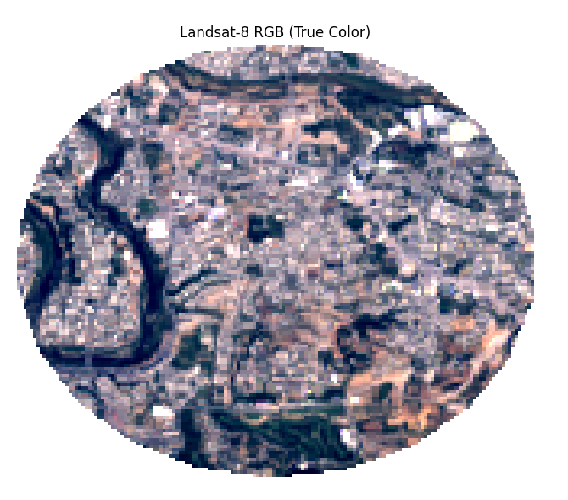
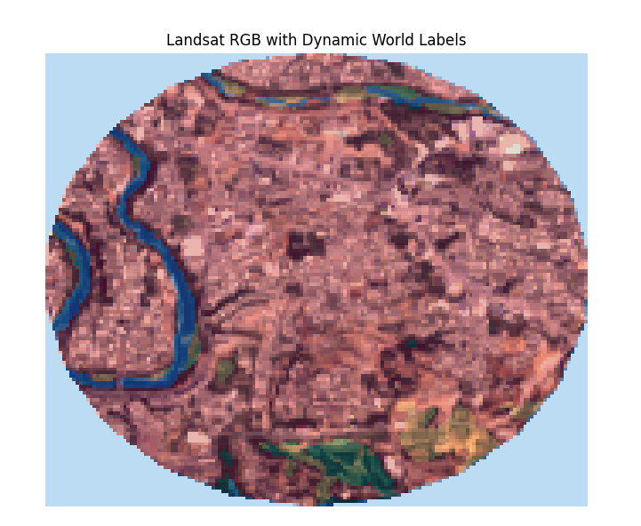
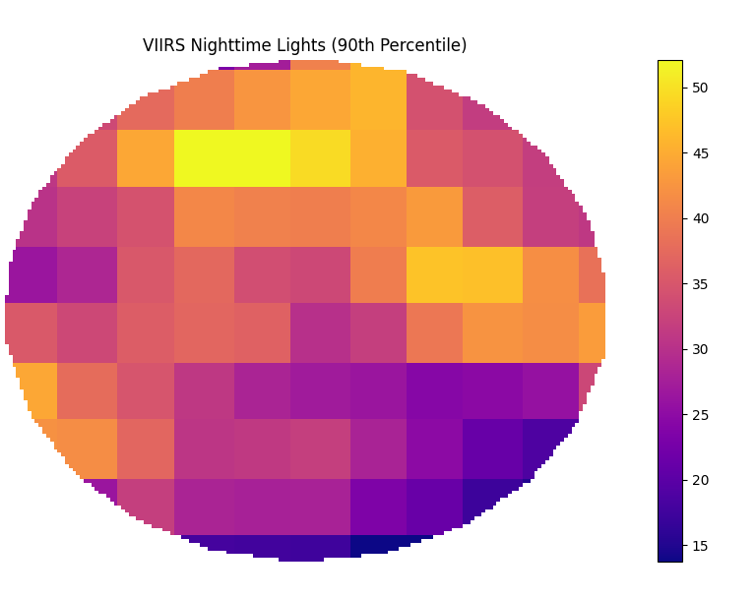
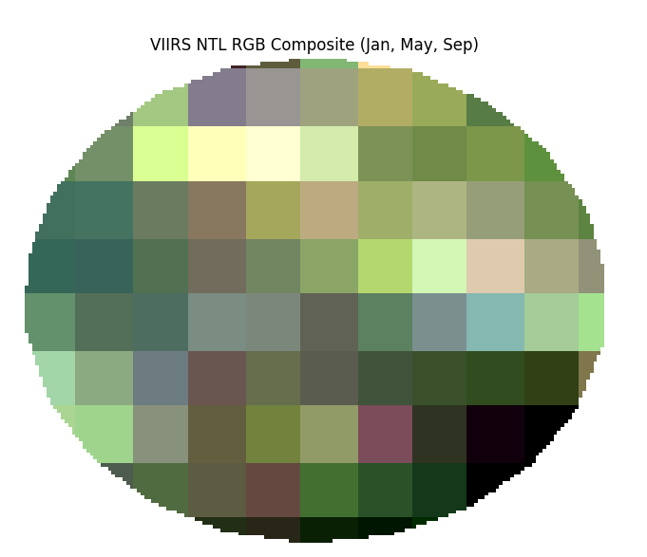
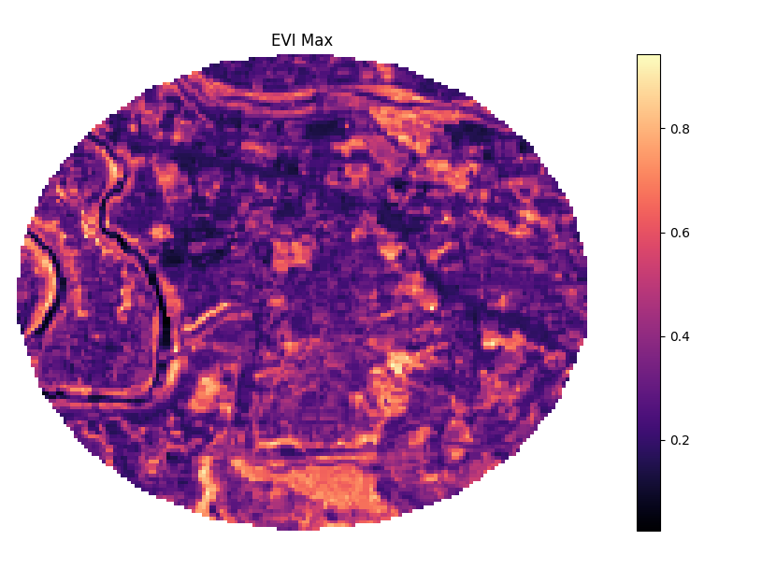
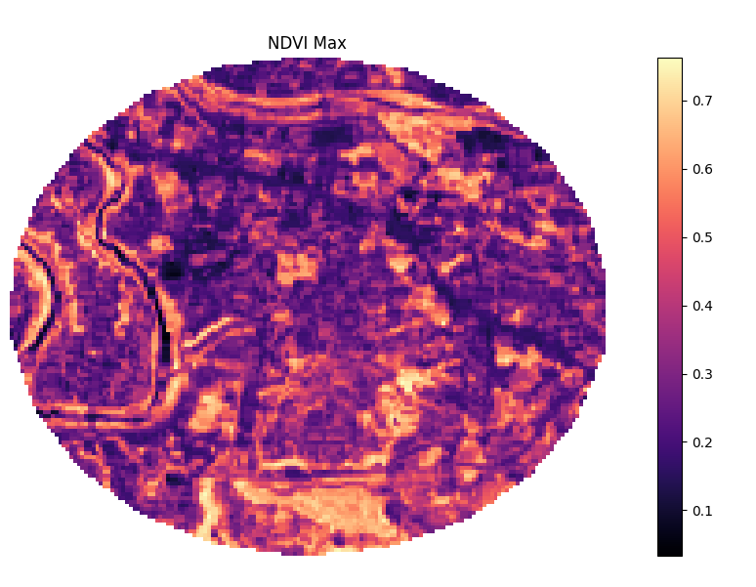
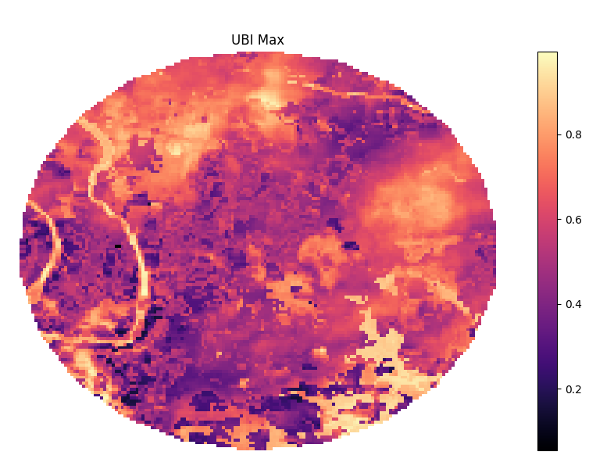
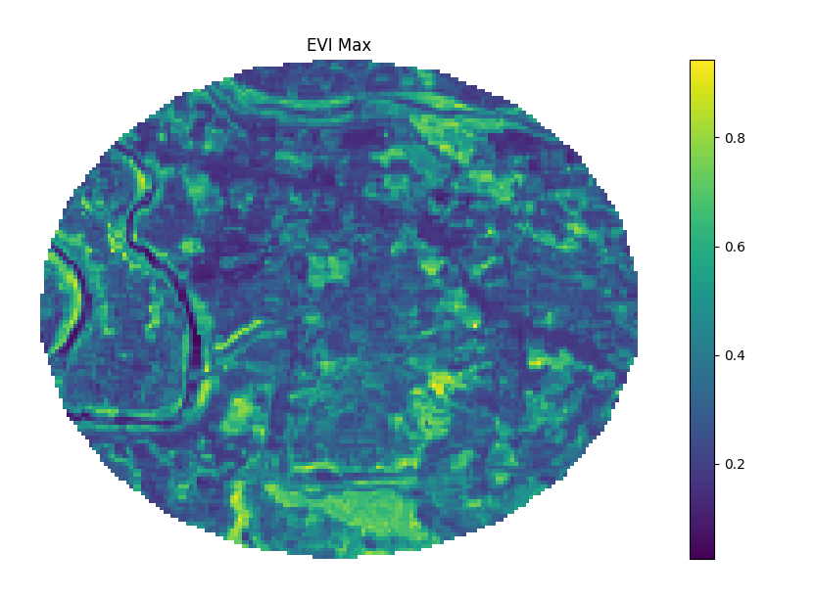
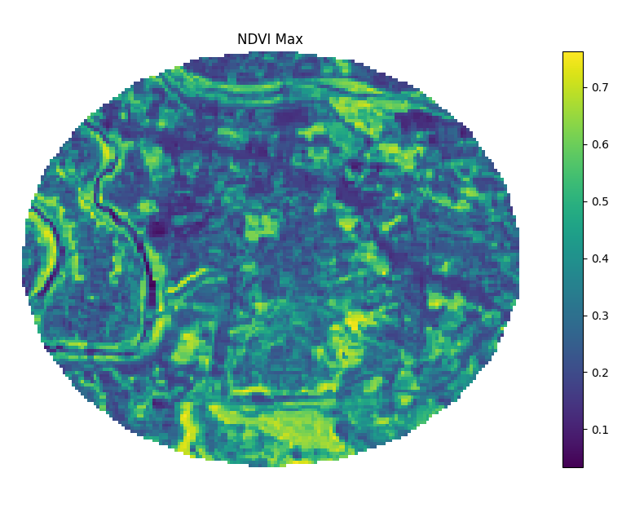
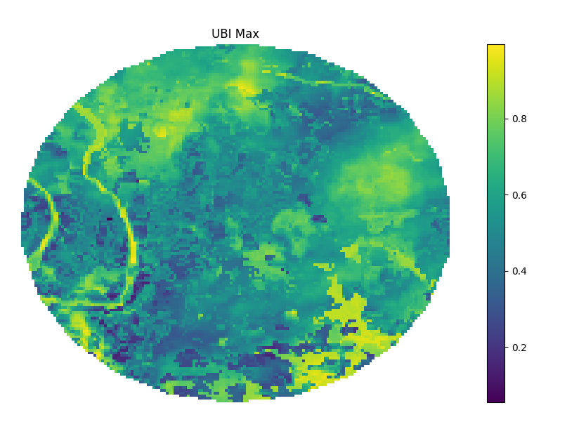
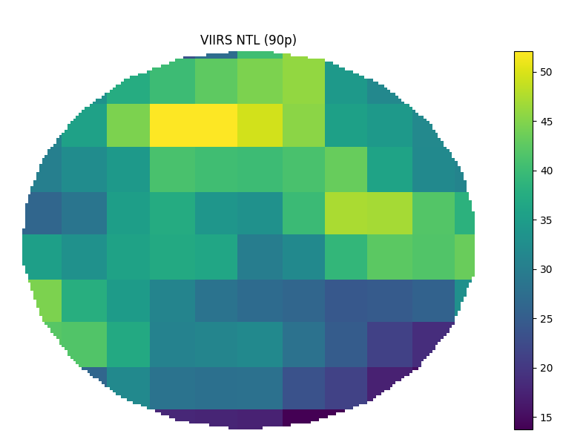

Landsat 8 Bands:
Band Number | Band Name | Wavelength (µm) | Spatial Resolution (m)
1 | Coastal /Aerosol | 0.43–0.45 | 30
2 | Blue | 0.45–0.51 | 30
3 | Green | 0.53–0.59 | 30
4 | Red | 0.64–0.67 | 30
5 | NIR | 0.85–0.88 | 30
6 | SWIR 1 | 1.57–1.65 | 30
7 | SWIR 2 | 2.11–2.29 | 30
8 | PAN (Panchromatic) | 0.50–0.68 | 15
9 | Cirrus | 1.36–1.38 | 30
10 | TIRS 1 (Thermal) | 10.6–11.19 | 100
11 | TIRS 2 (Thermal) | 11.50–12.51 | 100

Night Light (NTL) Urban Settlement Indices:
- Enhanced Urban Built-up Index (EUBI)
- Human Settlement Index (HSI)
- Vegetation Adjusted NTL Urban Index (VANUI)
- Large-scale Impervious Surface Index (LISI)
- Normalized Difference Urban Index (NDUI)
- Normalized Urban Areas Composite Index (NUACI)
- Nighttime Lights Adjusted Impervious Surface Index (NAISI)
The formulas of these are:
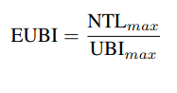
Where:
- UBI_{max}: Annual max of Urban Built-up Index from Landsat 8 HSV-transformed reflectance,
- NTL_{max}: 90th percentile VIIRS DNB nighttime light radiance.
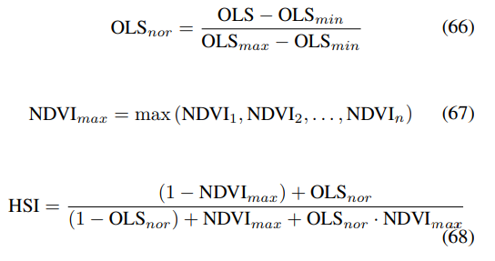
Here OLS = NTL

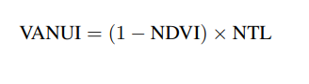
Where:
- NDVI: Normalized Difference Vegetation Index (from Landsat 8 NBAR reflectance),
- NTL: Normalized VIIRS nighttime light (scaled to [0,1]).

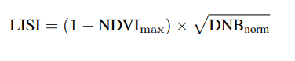
Where:
- NDVI_{max}: Seasonal maximum NDVI from Landsat 8 composites,
- DNB_{norm} = DNB−DNB_{min}/ DNB_{max}−DNB_{min} : Min–max normalized VIIRS-DNB radiance.

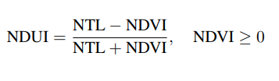
Where:
- NTL: Normalized VIIRS nightlight intensity scaled to [0, 1],
- NDVI: Cloud-free seasonal NDVI composite from Landsat 8.

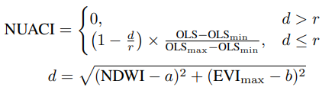

Where:
- d: Distance from urban centroid in NDWI–EVI space,
- a, b: Urban training mean values of NDWI and EVImax
- r: Radius of urban spectral zone (e.g., 0.4),
- OLS: Normalized VIIRS radiance value,
- OLS_{min}, OLS_{max}: Min/max OLS values in the study area

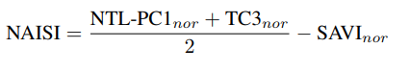
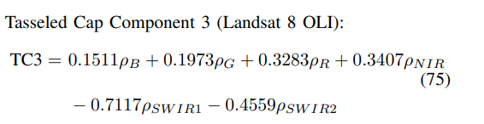
Where:
- NTL-PC1_{nor}: Normalized PC1 from NTL-ISS RGB composites,
- TC3_{nor}: Normalized third component from Landsat Tasseled Cap transformation,
- SAVI_{nor}: Normalized Soil-Adjusted Vegetation Index

The code used for implementation is:
import rasterio
import numpy as np
import matplotlib.pyplot as plt
from matplotlib.colors import ListedColormap
from sklearn.metrics import (
jaccard_score, confusion_matrix, accuracy_score, precision_score,
recall_score, f1_score, balanced_accuracy_score, cohen_kappa_score,
roc_curve, auc
)
from skimage.transform import resize
import pandas as pd
import matplotlib.patches as mpatches
import os

# ======= Settings =======
landsat_path = r'C:\Users\Adeel Ajmal\Downloads\L8_BahriaPhase7_20231012.tif'
label_path = r'C:\Users\Adeel Ajmal\Downloads\DynamicWorld_LandcoverLabels.tif'
viirs_path = r'C:\Users\Adeel Ajmal\Downloads\VIIRS_NTL_90p_BahriaPhase7_20230101_20250701.tif' # Update if needed
evi_max_path = r'C:\Users\Adeel Ajmal\Downloads\L8_EVImax_BahriaPhase7_20230101_20250701.tif'
ndvi_max_path = r'C:\Users\Adeel Ajmal\Downloads\L8_NDVImax_BahriaPhase7_20230101_20250701.tif'
viirs_rgb_path = r'C:\Users\Adeel Ajmal\Downloads\VIIRS_NTL_RGB_BahriaPhase7_2023.tif'
ubi_max_path = r'C:\Users\Adeel Ajmal\Downloads\UBImax_BahriaPhase7_20230101_20250701.tif'
outdir = "urban_index_eval_NTL_all"
save_figs = True
os.makedirs(outdir, exist_ok=True)

# ======= 1. Load Data =======
with rasterio.open(landsat_path) as src:
stack = src.read().astype('float32')
b1,b2,b3,b4,b5,b6,b7,b8,b9,b10,b11 = stack

with rasterio.open(label_path) as src:
labels = src.read(1)

with rasterio.open(viirs_path) as src:
viirs_ntl = src.read(1).astype('float32')

# Load annual max composites
with rasterio.open(evi_max_path) as src:
EVI_max = src.read(1).astype('float32')
with rasterio.open(ndvi_max_path) as src:
NDVI_max = src.read(1).astype('float32')

with rasterio.open(viirs_rgb_path) as src:
ntl_jan, ntl_may, ntl_sep = src.read()
# Normalize each band to [0, 1]
def norm(x): return (x - np.nanmin(x)) / (np.nanmax(x) - np.nanmin(x) + 1e-6)
ntl_jan_norm = norm(ntl_jan)
ntl_may_norm = norm(ntl_may)
ntl_sep_norm = norm(ntl_sep)
ntl_rgb = np.stack([ntl_jan_norm, ntl_may_norm, ntl_sep_norm], axis=-1)

with rasterio.open(ubi_max_path) as src:
UBI_max = src.read(1).astype('float32')

gt_mask = (labels == 6).astype(np.uint8)
gt_mask_resized = resize(
gt_mask,
(stack.shape[1], stack.shape[2]),
order=0, preserve_range=True, anti_aliasing=False
).astype(np.uint8)

# ======= 2. Define Indices (as per docx) =======
# Note: Add all requested indices here. All formulas are implemented below.
# For missing bands, formulas are adapted for Landsat 8. Each index is nan-masked if denominator can be zero.
def safe_div(num, denom):
out = np.full_like(num, np.nan)
valid = np.abs(denom) > 1e-6
out[valid] = num[valid] / denom[valid]
return out

indices = {}

# ---------- EXTRA PREP: Reflectance ratio bands (already float32) ----------
# Assumption: stack contains TOA reflectance for optical, TOA BT (Kelvin) for thermal.
rho_red = b4 # reflectance red
rho_nir = b5
rho_swir1= b6
rho_green= b3
rho_swir2= b7
rho_blue = b2

# ---------- 1. NDVI, MNDWI (unchanged) ----------
NDVI = safe_div(rho_nir - rho_red, rho_nir + rho_red)
MNDWI = safe_div(rho_green - rho_swir1, rho_green + rho_swir1)
NDWI = safe_div(rho_green - rho_nir, rho_green + rho_nir)

indices['NDVI'] = NDVI
indices['MNDWI'] = MNDWI

# ======= 4. Normalize VIIRS NTL =======
ntl_mask = np.isfinite(viirs_ntl) & (viirs_ntl > 0)
NTL_min = np.nanmin(viirs_ntl[ntl_mask])
NTL_max = np.nanmax(viirs_ntl[ntl_mask])
NTL_norm = np.zeros_like(viirs_ntl)
NTL_norm[ntl_mask] = (viirs_ntl[ntl_mask] - NTL_min) / (NTL_max - NTL_min)
NTL_norm[~ntl_mask] = 0

# Masked NTL for urban (optional, not used in index formulas, but you can analyze separately)
NTL_urban = NTL_norm * gt_mask_resized

# ======= Implement Urban NTL Indices (add to indices dictionary) =======

# 1. HSI: Human Settlement Index
# HSI = ((1 - NDVI_max) + NTL_norm) / ((1 - NTL_norm) + NDVI_max + NTL_norm * NDVI_max)
indices["HSI"] = safe_div((1 - NDVI_max) + NTL_norm, (1 - NTL_norm) + NDVI_max + NTL_norm * NDVI_max)

# # 2. VANUI: Vegetation Adjusted NTL Urban Index
indices["VANUI"] = (1 - NDVI) * NTL_norm

# # 3. LISI: Large-scale Impervious Surface Index
indices["LISI"] = (1 - NDVI_max) * np.sqrt(NTL_norm)

# # 4. NDUI: Normalized Difference Urban Index
# # NDUI = (NTL_norm - NDVI) / (NTL_norm + NDVI), NDVI >= 0
ndui_mask = (NDVI >= 0)
indices["NDUI"] = np.full_like(NDVI, np.nan)
indices["NDUI"][ndui_mask] = safe_div(NTL_norm[ndui_mask] - NDVI[ndui_mask], NTL_norm[ndui_mask] + NDVI[ndui_mask])

# 5. UBI: Urban Built-Up Index (Hue/Value method)
from matplotlib.colors import rgb_to_hsv

# c * Red: use c=2 as common in literature
c = 2.0
syn_rgb = np.stack([rho_nir, rho_swir1, c * rho_red], axis=-1)
# Normalize RGB to [0,1] for HSV
rgb_min = np.nanmin(syn_rgb, axis=(0,1))
rgb_max = np.nanmax(syn_rgb, axis=(0,1))
rgb_norm = (syn_rgb - rgb_min) / (rgb_max - rgb_min + 1e-6)
hsv = rgb_to_hsv(rgb_norm)
H = hsv[...,0]
V = hsv[...,2]
indices["UBI"] = safe_div(H - V, H + V)

# 6. EUBI: Enhanced Urban Built-up Index (EUBI = NTL_max / UBI_max)
EUBI = safe_div(NTL_norm, UBI_max)
indices["EUBI"] = EUBI

# # 7. NUACI: Normalized Urban Areas Composite Index

NDWI = safe_div(rho_green - rho_nir, rho_green + rho_nir)

# The Enhanced Vegetation Index (EVI) formula is: EVI = G * ((NIR - Red) / (NIR + C1 * Red - C2 * Blue + L)). This formula uses near-infrared (NIR), red (Red), and blue (Blue) reflectance values from remote sensing data. Constants G, C1, C2, and L are scaling factors used to adjust for atmospheric and background noise.
# Here's a breakdown of the components:
# NIR: Reflectance in the near-infrared band.
# Red: Reflectance in the red band.
# Blue: Reflectance in the blue band.
# G: Gain factor, usually 2.5.
# C1: Aerosol resistance term, usually 6.
# C2: Aerosol resistance term, usually 7.5.
# L: Canopy background adjustment, usually 1.
# The EVI is designed to be more sensitive to changes in vegetation and less susceptible to atmospheric effects than other vegetation indices like NDVI. It is particularly useful in areas with dense vegetation and for reducing the impact of atmospheric conditions.

# --- After band assignment ---
G = 2.5
C1 = 6.0
C2 = 7.5
L = 1.0
EVI = G * (rho_nir - rho_red) / (rho_nir + C1 * rho_red - C2 * rho_blue + L)
indices['EVI'] = EVI

ndwi_urban = NDWI[gt_mask_resized == 1]
evi_max_urban = EVI_max[gt_mask_resized == 1] # <--- use annual max EVI here!

a = np.nanmean(ndwi_urban)
b = np.nanmean(evi_max_urban)
r_base = np.sqrt(np.nanvar(ndwi_urban) + np.nanvar(evi_max_urban))

print(f"NUACI centroid: a={a:.4f}, b={b:.4f}, radius={r_base:.4f}")
# r_factors = [1.0, 1.25, 1.5, 2.0, 2.25, 2.5, 3, 3.2, 3.5, 4, 4.2, 4.5, 5] # Try original and larger radii
radius_factor = 2.25 # <<< Use this value, based on your IoU/F1 analysis
r = r_base * radius_factor

print(f"NUACI centroid: a={a:.4f}, b={b:.4f}, radius={r:.4f} (factor {radius_factor})")

# --- Compute NUACI with this radius ---
d = np.sqrt((NDWI - a)**2 + (EVI_max - b)**2)
cond = (d <= r)
OLS = NTL_norm
OLS_min = np.nanmin(OLS)
OLS_max = np.nanmax(OLS)
norm_OLS = (OLS - OLS_min) / (OLS_max - OLS_min + 1e-6)

NUACI = np.zeros_like(NDWI)
NUACI[cond] = (1 - d[cond] / r) * norm_OLS[cond]

indices["NUACI"] = NUACI

# from collections import OrderedDict
# nuaci_stats = OrderedDict()

# for factor in r_factors:
# r = r_base * factor
# d = np.sqrt((NDWI - a)**2 + (EVI_max - b)**2)
# cond = (d <= r)
# # Normalize OLS for the full image
# OLS = NTL_norm
# OLS_min = np.nanmin(OLS)
# OLS_max = np.nanmax(OLS)
# norm_OLS = (OLS - OLS_min) / (OLS_max - OLS_min + 1e-6)
# NUACI = np.zeros_like(NDWI)
# NUACI[cond] = (1 - d[cond] / r) * norm_OLS[cond]

# thr = best_threshold(NUACI, gt_mask_resized)
# pred = ((NUACI > thr) & (NDVI < 0.50)).astype(np.uint8)
# stats = metrics(pred, gt_mask_resized, idx_pred_scores=NUACI)
# nuaci_stats[factor] = stats
# print(f"Radius = {r:.3f} (factor {factor}): IoU={stats['IoU']:.3f}, Precision={stats['Pr']:.3f}, Recall={stats['Re']:.3f}, F1={stats['F1']:.3f}, TP={stats['TP']}")
# # --- Optional: Print all results together ---
# print("\nRadius Factor | IoU | Precision | Recall | F1 | TP")
# for factor, stats in nuaci_stats.items():
# print(f"{factor:12} | {stats['IoU']:.4f} | {stats['Pr']:.4f} | {stats['Re']:.4f} | {stats['F1']:.4f} | {stats['TP']}")

# # 8. NAISI: Nighttime Lights Adjusted Impervious Surface Index
# # For simplicity, you can skip PC1 and use NTL_norm
# # Tasseled Cap TC3 (need to calculate with Landsat coefficients)
from sklearn.decomposition import PCA
h, w, c = ntl_rgb.shape
flat = ntl_rgb.reshape(-1, 3)
flat_no_nan = np.nan_to_num(flat, nan=0.0) # or use mean imputation if desired
pc1 = PCA(n_components=1).fit_transform(flat_no_nan).reshape(h, w)
pc1_mask = np.all(np.isfinite(ntl_rgb), axis=-1)
pc1[~pc1_mask] = np.nan
PC1_norm = (pc1 - np.nanmin(pc1)) / (np.nanmax(pc1) - np.nanmin(pc1) + 1e-6)

TC3 = 0.1511*rho_blue + 0.1973*rho_green + 0.3283*rho_red + 0.3407*rho_nir - 0.7117*rho_swir1 - 0.4559*rho_swir2
SAVI = safe_div(1.5 * (rho_nir - rho_red), rho_nir + rho_red + 0.5)
SAVI_norm = (SAVI - np.nanmin(SAVI)) / (np.nanmax(SAVI) - np.nanmin(SAVI) + 1e-6)
TC3_norm = (TC3 - np.nanmin(TC3)) / (np.nanmax(TC3) - np.nanmin(TC3) + 1e-6)
NAISI = PC1_norm + TC3_norm - 2*SAVI_norm / 2

indices["NAISI"] = NAISI

# ======= 7. NDVI Threshold Search & Best Mask =======
ndvi_thresholds = np.arange(0.1, 0.81, 0.05)
best_results = {}
all_results = {}

def best_threshold(idx, truth, n_steps=200):
v = np.isfinite(idx) & np.isfinite(truth)
x, y = idx[v].ravel(), truth[v].ravel()
best_thr, best_iou = None, -1
for thr in np.linspace(np.nanmin(x), np.nanmax(x), n_steps):
y_pred = (x > thr).astype(np.uint8)
if y_pred.sum() == 0: continue
iou = jaccard_score(y, y_pred, zero_division=0)
if iou > best_iou: best_thr, best_iou = thr, iou
return best_thr

def metrics(mask_pred, truth, idx_pred_scores=None):
v = np.isfinite(mask_pred) & np.isfinite(truth)
y_pred, y_true = mask_pred[v].ravel(), truth[v].ravel()
out = dict(
IoU=jaccard_score(y_true, y_pred, zero_division=0),
F1=f1_score(y_true, y_pred, zero_division=0),
Pr=precision_score(y_true, y_pred, zero_division=0),
Re=recall_score(y_true, y_pred, zero_division=0),
Acc=accuracy_score(y_true, y_pred),
BAc=balanced_accuracy_score(y_true, y_pred),
Kappa=cohen_kappa_score(y_true, y_pred)
)
tn, fp, fn, tp = confusion_matrix(y_true, y_pred, labels=[0,1]).ravel()
out.update({"TP":tp,"TN":tn,"FP":fp,"FN":fn})
if idx_pred_scores is not None:
v2 = v & np.isfinite(idx_pred_scores)
y_true2 = truth[v2].ravel()
y_score2 = idx_pred_scores[v2].ravel()
if len(np.unique(y_true2)) > 1 and len(y_score2) > 0:
try:
fpr, tpr, _ = roc_curve(y_true2, y_score2)
out["AUC"] = auc(fpr, tpr)
except Exception as e:
out["AUC"] = np.nan
else:
out["AUC"] = np.nan
else:
out["AUC"] = np.nan
return out

for idx_name, idx in indices.items():
metric_by_thr = []
for ndvi_thr in ndvi_thresholds:
thr = best_threshold(idx, gt_mask_resized)
pred = ((idx > thr) & (NDVI < ndvi_thr)).astype(np.uint8)
result = metrics(pred, gt_mask_resized, idx_pred_scores=idx)
result['ndvi_thr'] = ndvi_thr
result['idx_thr'] = thr
metric_by_thr.append(result)
df_thr = pd.DataFrame(metric_by_thr)
best_i = df_thr['IoU'].idxmax()
best_results[idx_name] = df_thr.loc[best_i].to_dict()
all_results[idx_name] = df_thr

# ======= 8. Visualization: 3-panel for Each Index =======
class_palette = [
"#419bdf", "#397d49", "#88b053", "#7a87c6", "#e49635",
"#dfc35a", "#c4281b", "#a59b8f", "#ffffff"
]
class_names = [
"Water", "Trees", "Grass", "Flooded Veg", "Crops",
"Shrub/Scrub", "Built", "Bare", "Snow/Ice"
]
label_viz = resize(labels, (stack.shape[1], stack.shape[2]), order=0, preserve_range=True, anti_aliasing=False)

rgb = np.stack([b4, b3, b2], -1)
p2, p98 = np.nanpercentile(rgb, (2, 98))
rgb = np.clip((rgb - p2) / (p98 - p2), 0, 1)
rgb[np.isnan(rgb)] = 0

URBAN_COLOR = np.array([1.0, 0.1, 0.1])
NON_URBAN_COLOR = np.array([0.65, 0.65, 0.65])

for idx_name, idx in indices.items():
best = best_results[idx_name]
ndvi_thr = best['ndvi_thr']
idx_thr = best['idx_thr']
pred = ((idx > idx_thr) & (NDVI < ndvi_thr)).astype(np.uint8)

fig, axs = plt.subplots(1, 3, figsize=(22, 7))
axs[0].imshow(rgb)
axs[0].set_title("Landsat-8 RGB")
axs[0].axis('off')

im2 = axs[1].imshow(label_viz, cmap=ListedColormap(class_palette), vmin=0, vmax=8)
axs[1].set_title("Dynamic World Labels")
axs[1].axis('off')
cbar = plt.colorbar(im2, ax=axs[1], ticks=np.arange(0,9), shrink=0.8)
cbar.ax.set_yticklabels(class_names)

idx_disp = np.copy(idx)
idx_disp[~np.isfinite(idx_disp)] = np.nan
axs[2].imshow(idx_disp, cmap='RdYlBu')
gt_viz = np.zeros((*gt_mask_resized.shape, 3), dtype=np.float32)
gt_viz[gt_mask_resized == 1] = URBAN_COLOR
gt_viz[gt_mask_resized == 0] = NON_URBAN_COLOR
pred_viz = np.zeros((*pred.shape, 3), dtype=np.float32)
pred_viz[pred == 1] = URBAN_COLOR
pred_viz[pred == 0] = NON_URBAN_COLOR
axs[2].imshow(0.6*gt_viz + 0.4*pred_viz, alpha=0.45)
axs[2].set_title(f"{idx_name} Index\nIoU={best['IoU']:.3f} NDVI<{ndvi_thr:.2f}")
axs[2].axis('off')
handles = [
mpatches.Patch(color=URBAN_COLOR, label='Urban'),
mpatches.Patch(color=NON_URBAN_COLOR, label='Non-Urban')
]
axs[2].legend(handles=handles, loc='lower right', fontsize=12)
plt.tight_layout()
if save_figs:
plt.savefig(os.path.join(outdir, f"{idx_name}_urban3panel.png"), dpi=200, bbox_inches='tight')
plt.show()

# ======= 9. Save Summary Table =======
header = "{:<10} {:>8} {:>8} {:>8} {:>8} {:>8} {:>8} {:>8} {:>8} {:>6} {:>8}".format(
"Index","IoU","F1","Pr","Re","Acc","BAc","Kappa","AUC","TP","NDVI_thr")
print(header)
print("-"*len(header))
for k,v in best_results.items():
print("{:<10} {:8.3f} {:8.3f} {:8.3f} {:8.3f} {:8.3f} {:8.3f} {:8.3f} {:8.3f} {:6.0f} {:8.2f}".format(
k, v['IoU'], v['F1'], v['Pr'], v['Re'], v['Acc'], v['BAc'], v['Kappa'], v['AUC'], v['TP'], v['ndvi_thr']))
df = pd.DataFrame(best_results).T
df.to_csv(os.path.join(outdir, "urban_index_metrics_best.csv"))
for k, df_thr in all_results.items():
df_thr.to_csv(os.path.join(outdir, f"{k}_ndvi_threshold_sweep.csv"))
print("GT Urban Fraction: {:.2%}".format(gt_mask_resized.mean()))
vals, counts = np.unique(label_viz.astype(int), return_counts=True)
total = label_viz.size
print("\n--- Land Cover Breakdown (Dynamic World) ---")
for v, c in zip(vals, counts):
print(f"{class_names[v]:<12}: {c/total*100:5.2f}%")

import numpy as np
import matplotlib.pyplot as plt
from sklearn.metrics import confusion_matrix
import seaborn as sns
import os

def plot_confusion_matrix(y_true, y_pred, idx_name, outdir, labels=['Non-Urban', 'Urban']):
cm = confusion_matrix(y_true, y_pred, labels=[0,1])
plt.figure(figsize=(4,4))
sns.heatmap(cm, annot=True, fmt='d', cmap='Blues',
xticklabels=labels, yticklabels=labels,
cbar=False)
plt.xlabel('Predicted Label')
plt.ylabel('True Label')
plt.title(f'{idx_name} - Confusion Matrix')
plt.tight_layout()
# Save the figure
plt.savefig(os.path.join(outdir, f"{idx_name}_confusion_matrix.png"), dpi=150)
plt.close()

# Main loop: Go through all indices
for idx_name, idx in indices.items():
best = best_results[idx_name]
ndvi_thr = best['ndvi_thr']
idx_thr = best['idx_thr']
pred = ((idx > idx_thr) & (NDVI < ndvi_thr)).astype(np.uint8)
y_true = gt_mask_resized.ravel()
y_pred = pred.ravel()
plot_confusion_matrix(y_true, y_pred, idx_name, outdir)

print(f"Confusion matrix PNGs saved to {outdir}")

Output:
EUBI Result:
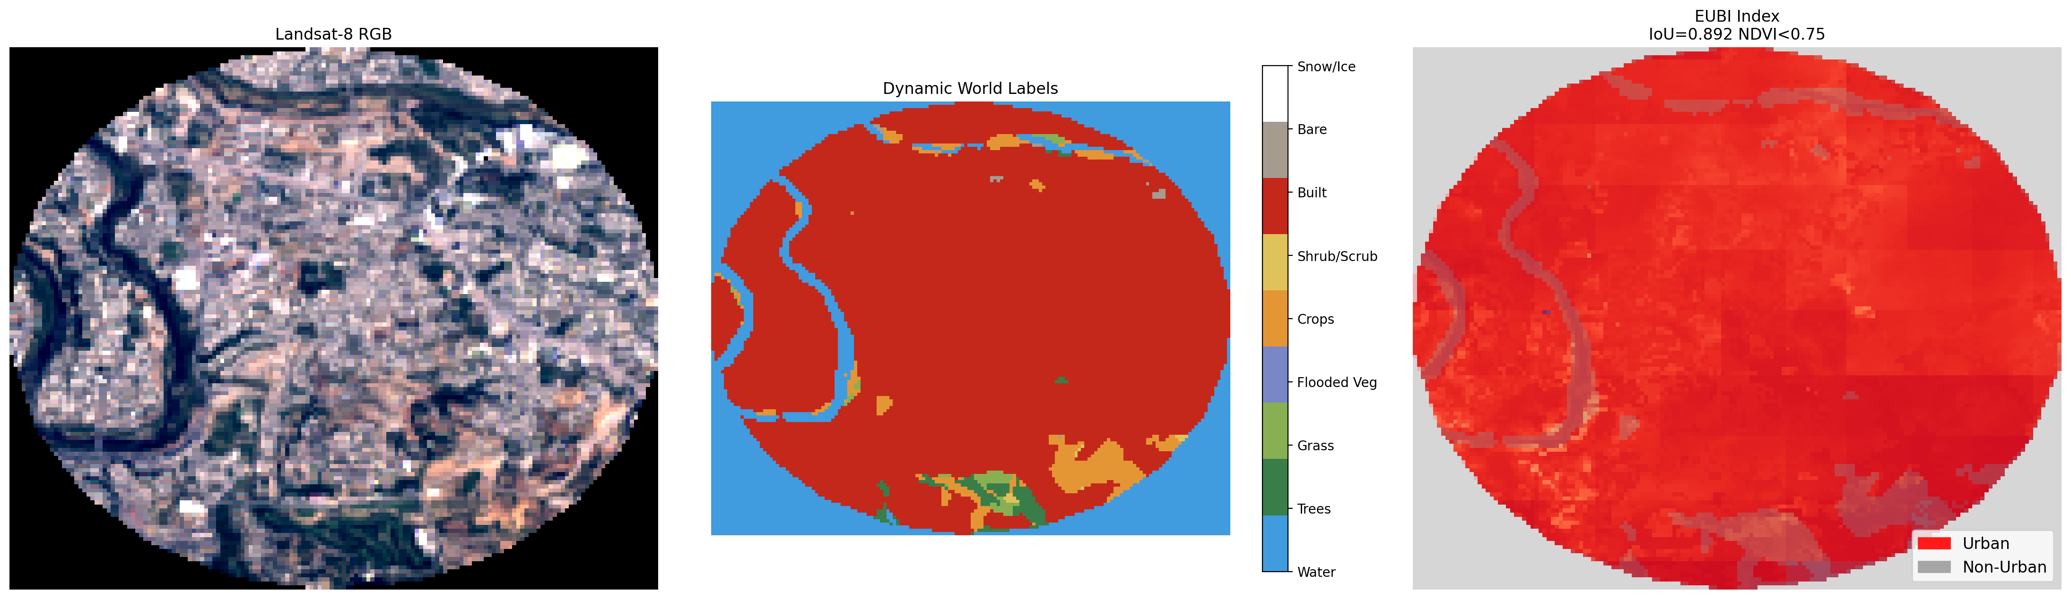

HSI Result:
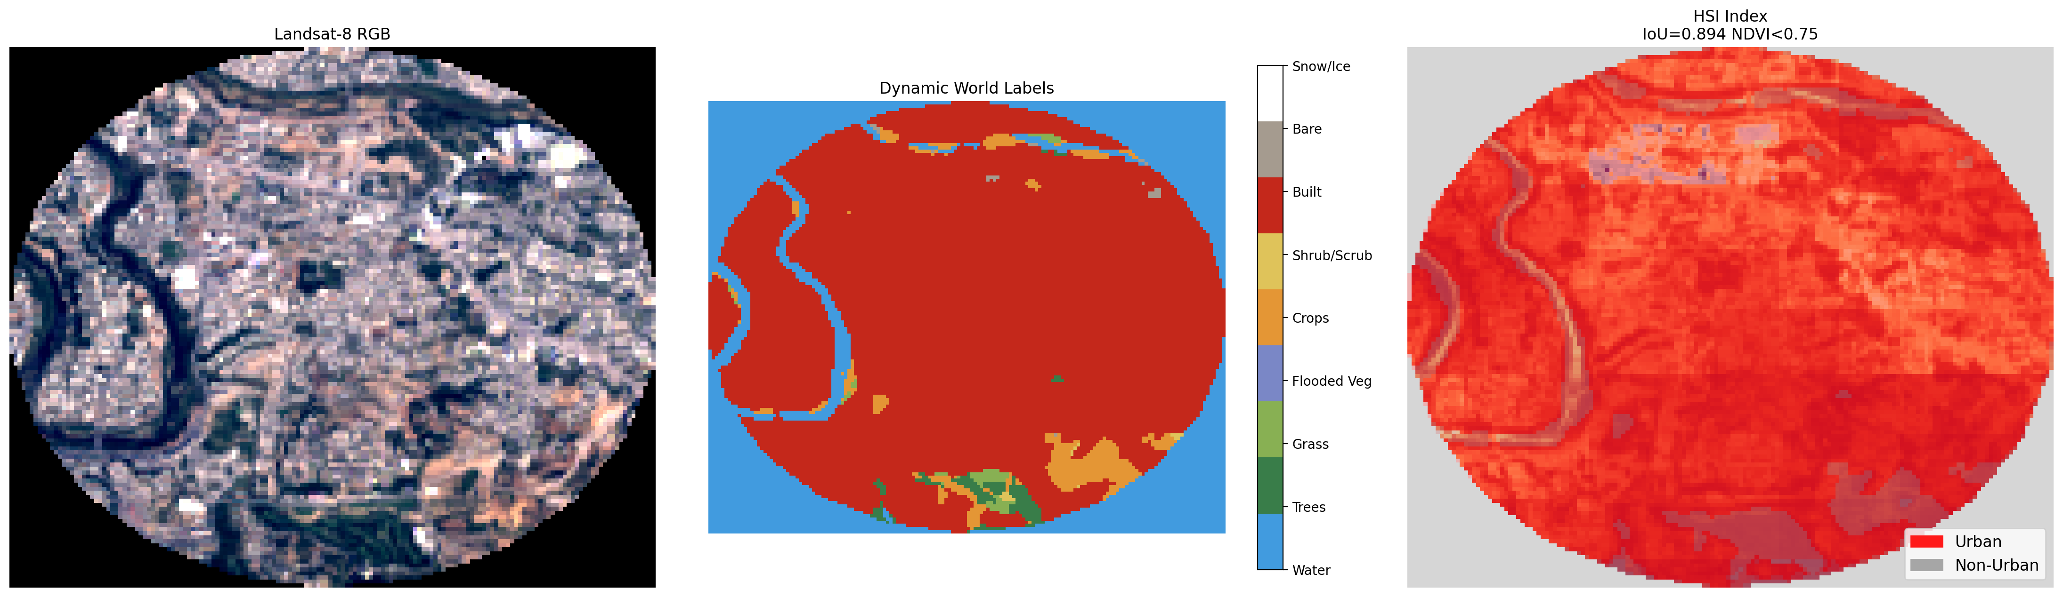
LISI Result:
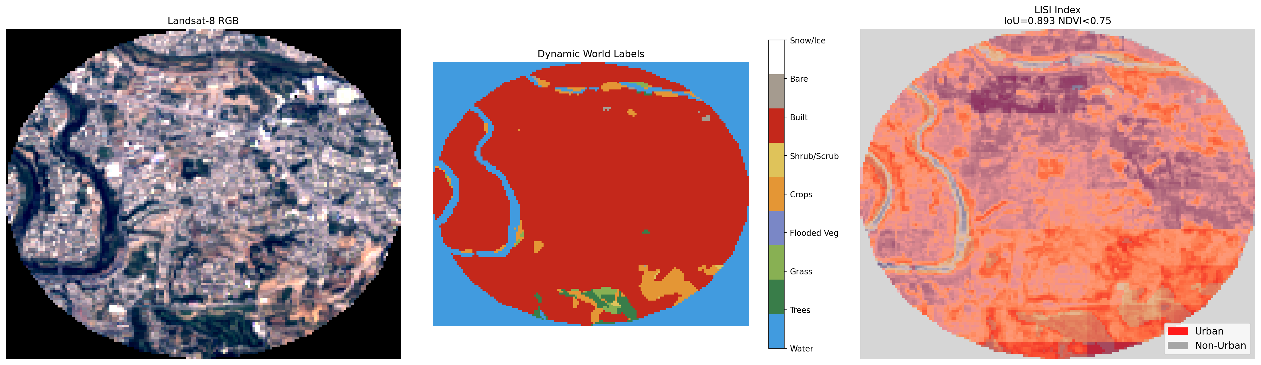
NAISI Result:
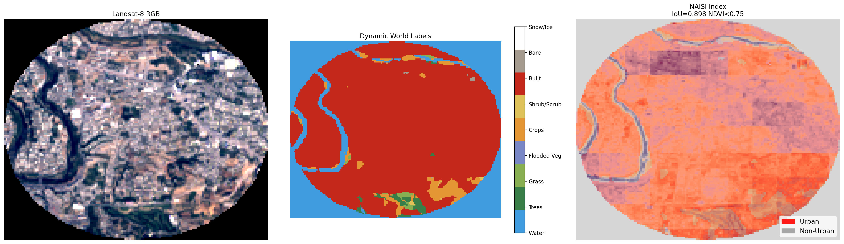
NDUI Result:
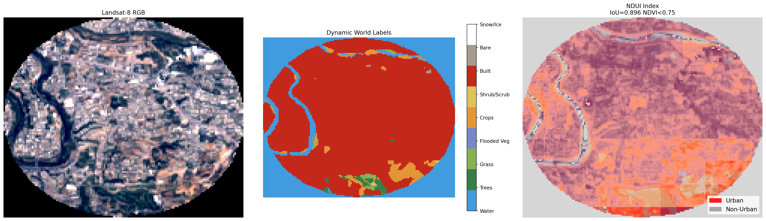
NUACI Result:
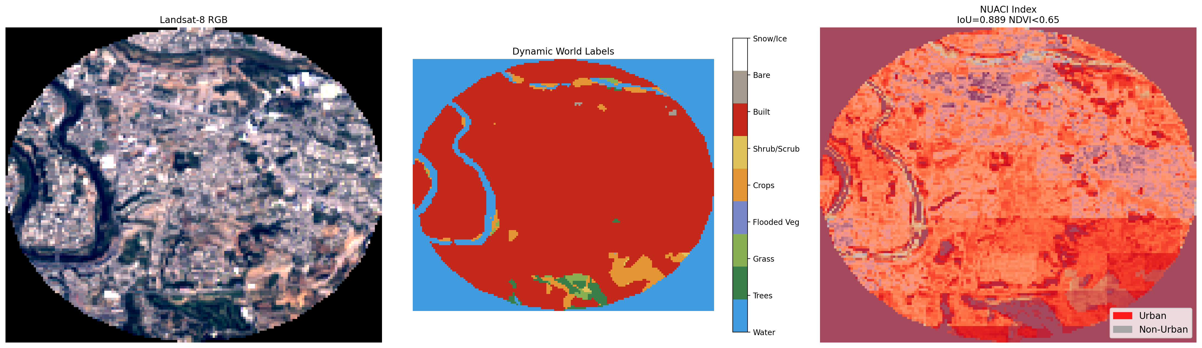
VANUI Result:
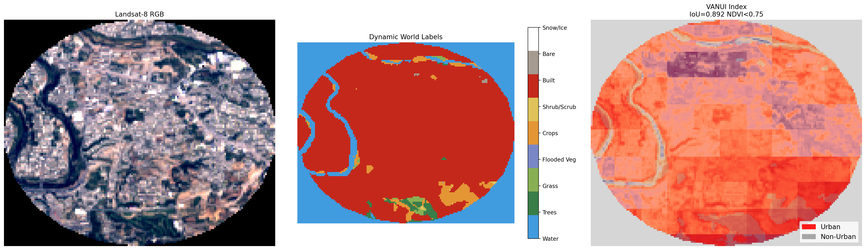

Metrics Result For Each Index:
Index Name | IoU-score | F1-score | Precision | Recall | Accuracy | Balanced Accuracy Score | Kappa Score
HSI | 0.893641 | 0.943834 | 0.895986 | 0.99708 | 0.916604 | 0.861713 | 0.783742
VANUI | 0.892406 | 0.943144 | 0.897542 | 0.993628 | 0.915812 | 0.862733 | 0.782614
LISI | 0.892774 | 0.94335 | 0.897049 | 0.99469 | 0.916045 | 0.862401 | 0.78293
NDUI | 0.896186 | 0.945251 | 0.901475 | 0.993496 | 0.919123 | 0.868394 | 0.791927
EUBI | 0.891884 | 0.942853 | 0.896043 | 0.994823 | 0.915252 | 0.860977 | 0.780654
NUACI | 0.889396 | 0.941461 | 0.915262 | 0.969204 | 0.915299 | 0.87853 | 0.788768
NAISI | 0.897792 | 0.946144 | 0.912515 | 0.982346 | 0.921409 | 0.879844 | 0.801525

Index Name | True Positives | True Negatives | False Positives | False Negatives | Area Under the Curve | NDVI threshold
HSI | 15023 | 4629 | 1744 | 44 | 0.732887 | 0.75
VANUI | 14971 | 4664 | 1709 | 96 | 0.697971 | 0.75
LISI | 14987 | 4653 | 1720 | 80 | 0.736573 | 0.75
NDUI | 14969 | 4737 | 1636 | 98 | 0.721881 | 0.75
EUBI | 14989 | 4634 | 1739 | 78 | 0.682464 | 0.75
NUACI | 14603 | 5021 | 1352 | 464 | 0.923538 | 0.65
NAISI | 14801 | 4954 | 1419 | 266 | 0.611656 | 0.75

For the correct calculation of NAUCI, different radius was tested then the best radius was selected based on the results we got. The results of different radius were:
Radius | IoU | Precision | Recall | F1
1.0 | 0.6573 | 0.9343 | 0.6892 | 0.7932
1.25 | 0.7668 | 0.9327 | 0.8116 | 0.8680
1.50 | 0.8281 | 0.9316 | 0.8817 | 0.9060
2.0 | 0.866 | 0.925 | 0.931 | 0.928
2.25 | 0.8706 | 0.9228 | 0.9389 | 0.9308
2.50 | 0.8708 | 0.9221 | 0.9399 | 0.9309
3.0 | 0.8705 | 0.9245 | 0.9371 | 0.9307
3.25 | 0.8702 | 0.9232 | 0.9381 | 0.9306
3.50 | 0.8690 | 0.9186 | 0.9415 | 0.9299
4.0 | 0.8685 | 0.9208 | 0.9386 | 0.9296
4.25 | 0.8684 | 0.9185 | 0.9408 | 0.9295
4.50 | 0.8675 | 0.9169 | 0.9415 | 0.9290
5.0 | 0.8679 | 0.9179 | 0.9409 | 0.9293

So as we increased the radius, IOU, recall, F1 score increased to around 3.0 radius but after that it started decreasing. So ultimately radius range that was good was from 2-3. So 2.25 radius was selected.
Confusion Matrices of Indices:
